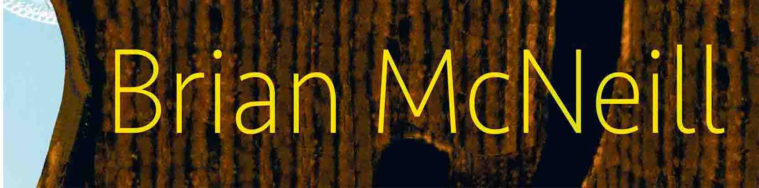

Brian’s Website

brian58@talktalk.net

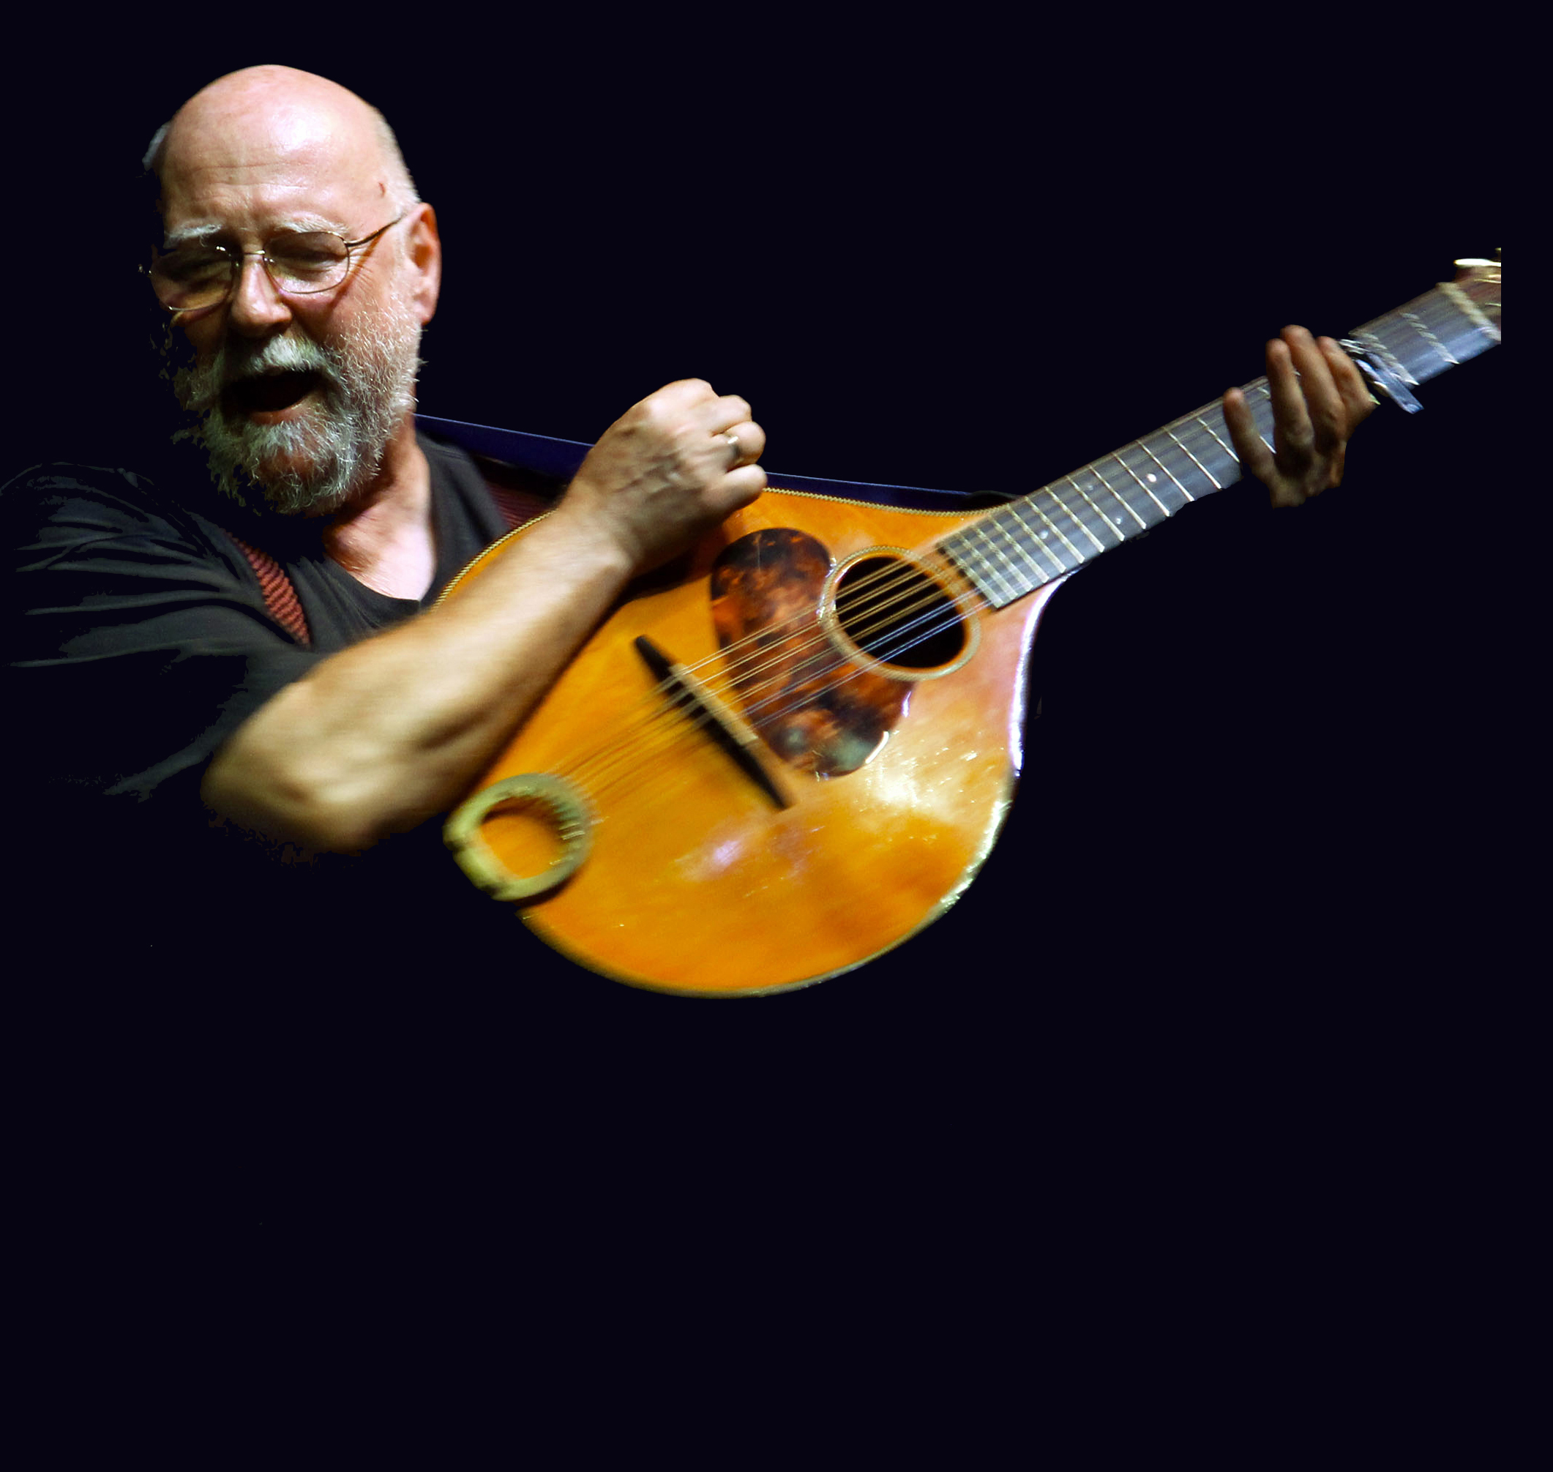
Hello everyone, and welcome to the first of my new newsletters.

2019 marks an important milestone for me - the 50th anniversary of my involvement in traditional music.

If anyone had told me back in 1969 that I’d manage to make a living doing what I love for the next half century, I’d have told them they were crazy, but it turned out I was the crazy one! The odd thing is that it still feels, somehow, as though I’m just beginning. As part of my celebrations, I’m putting together a new album, No Silence, which will feature a few of my most requested songs, as well as new ones which I hope will address some of the craziness of the world we now find ourselves in.
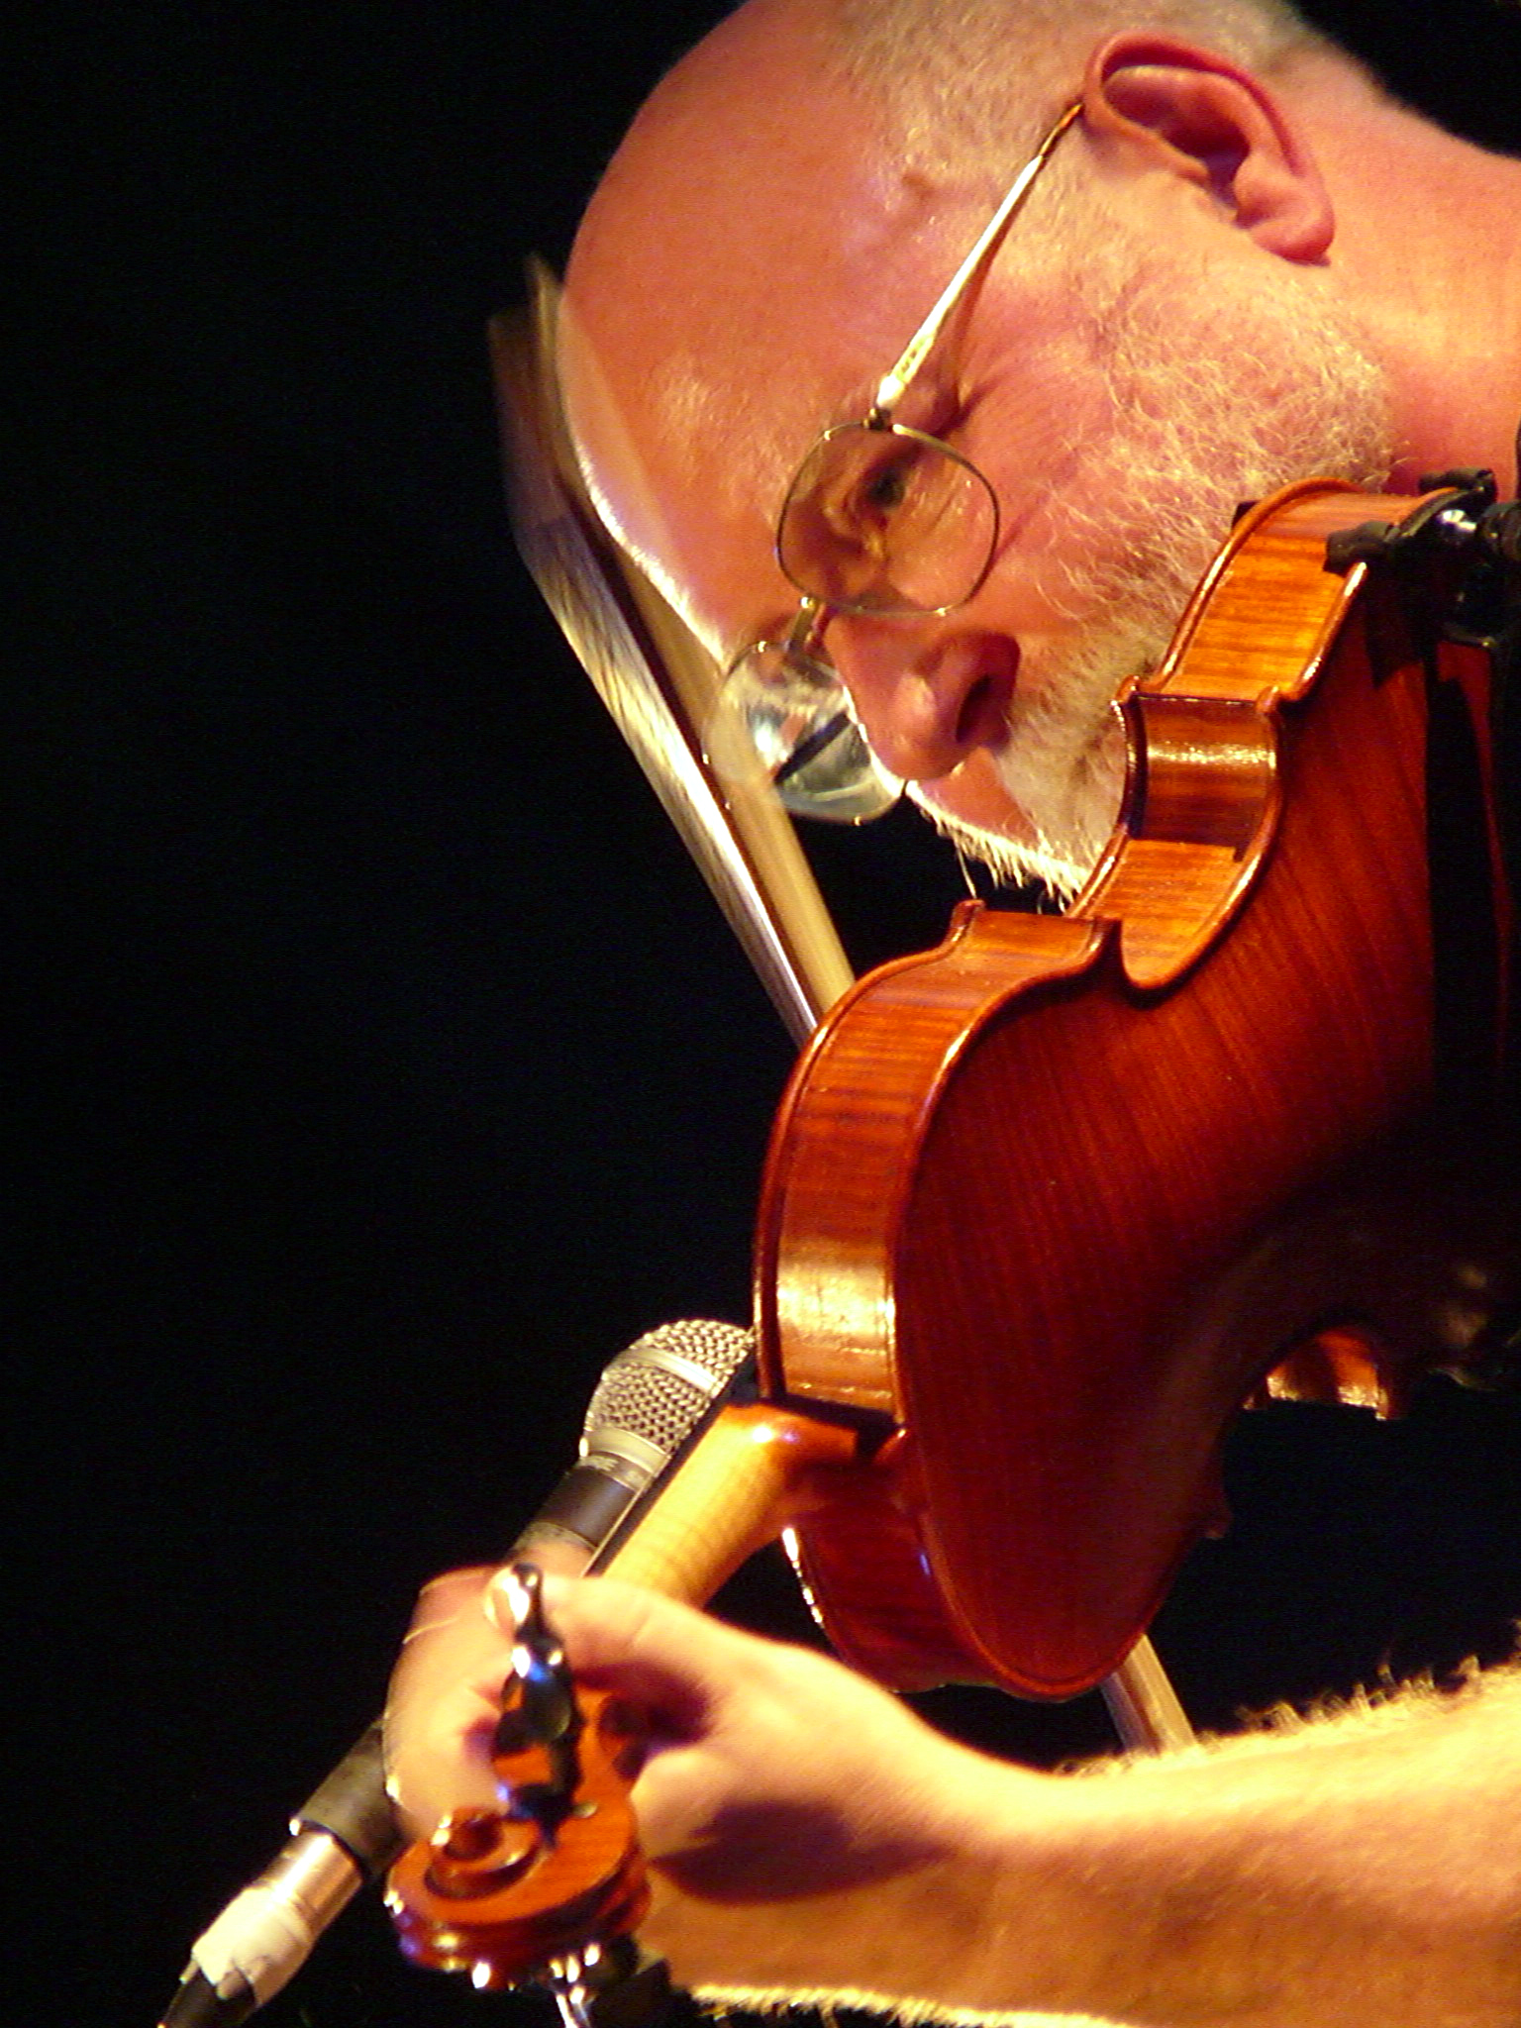
The first stage I’ll be on this year is the wonderful North Texas Irish Festival in Dallas. It’s one of the USA’s best gatherings of traditional music, and I’m particularly delighted to be part of it this year, because, as well as meeting all my old Texas sparring partners, I’ll be sharing a song or two with The Wee Heavies, a wonderful acapella quartet from St. Louis. I had the honour of producing their last album, Times Long Gone. Great friends and great music make for an unbeatable combination!

Hard on the heels of America comes the 25th annual Feast of Fiddles tour, which begins in March and takes us around England. We’ve had the first rehearsals, and it’s already sounding great. It’s always a pleasure to join my musical co-conspirators, gently plotting whatever brand of traditional (and not so traditional!) anarchy we can come up with this time round. Come to the concerts and help us celebrate!
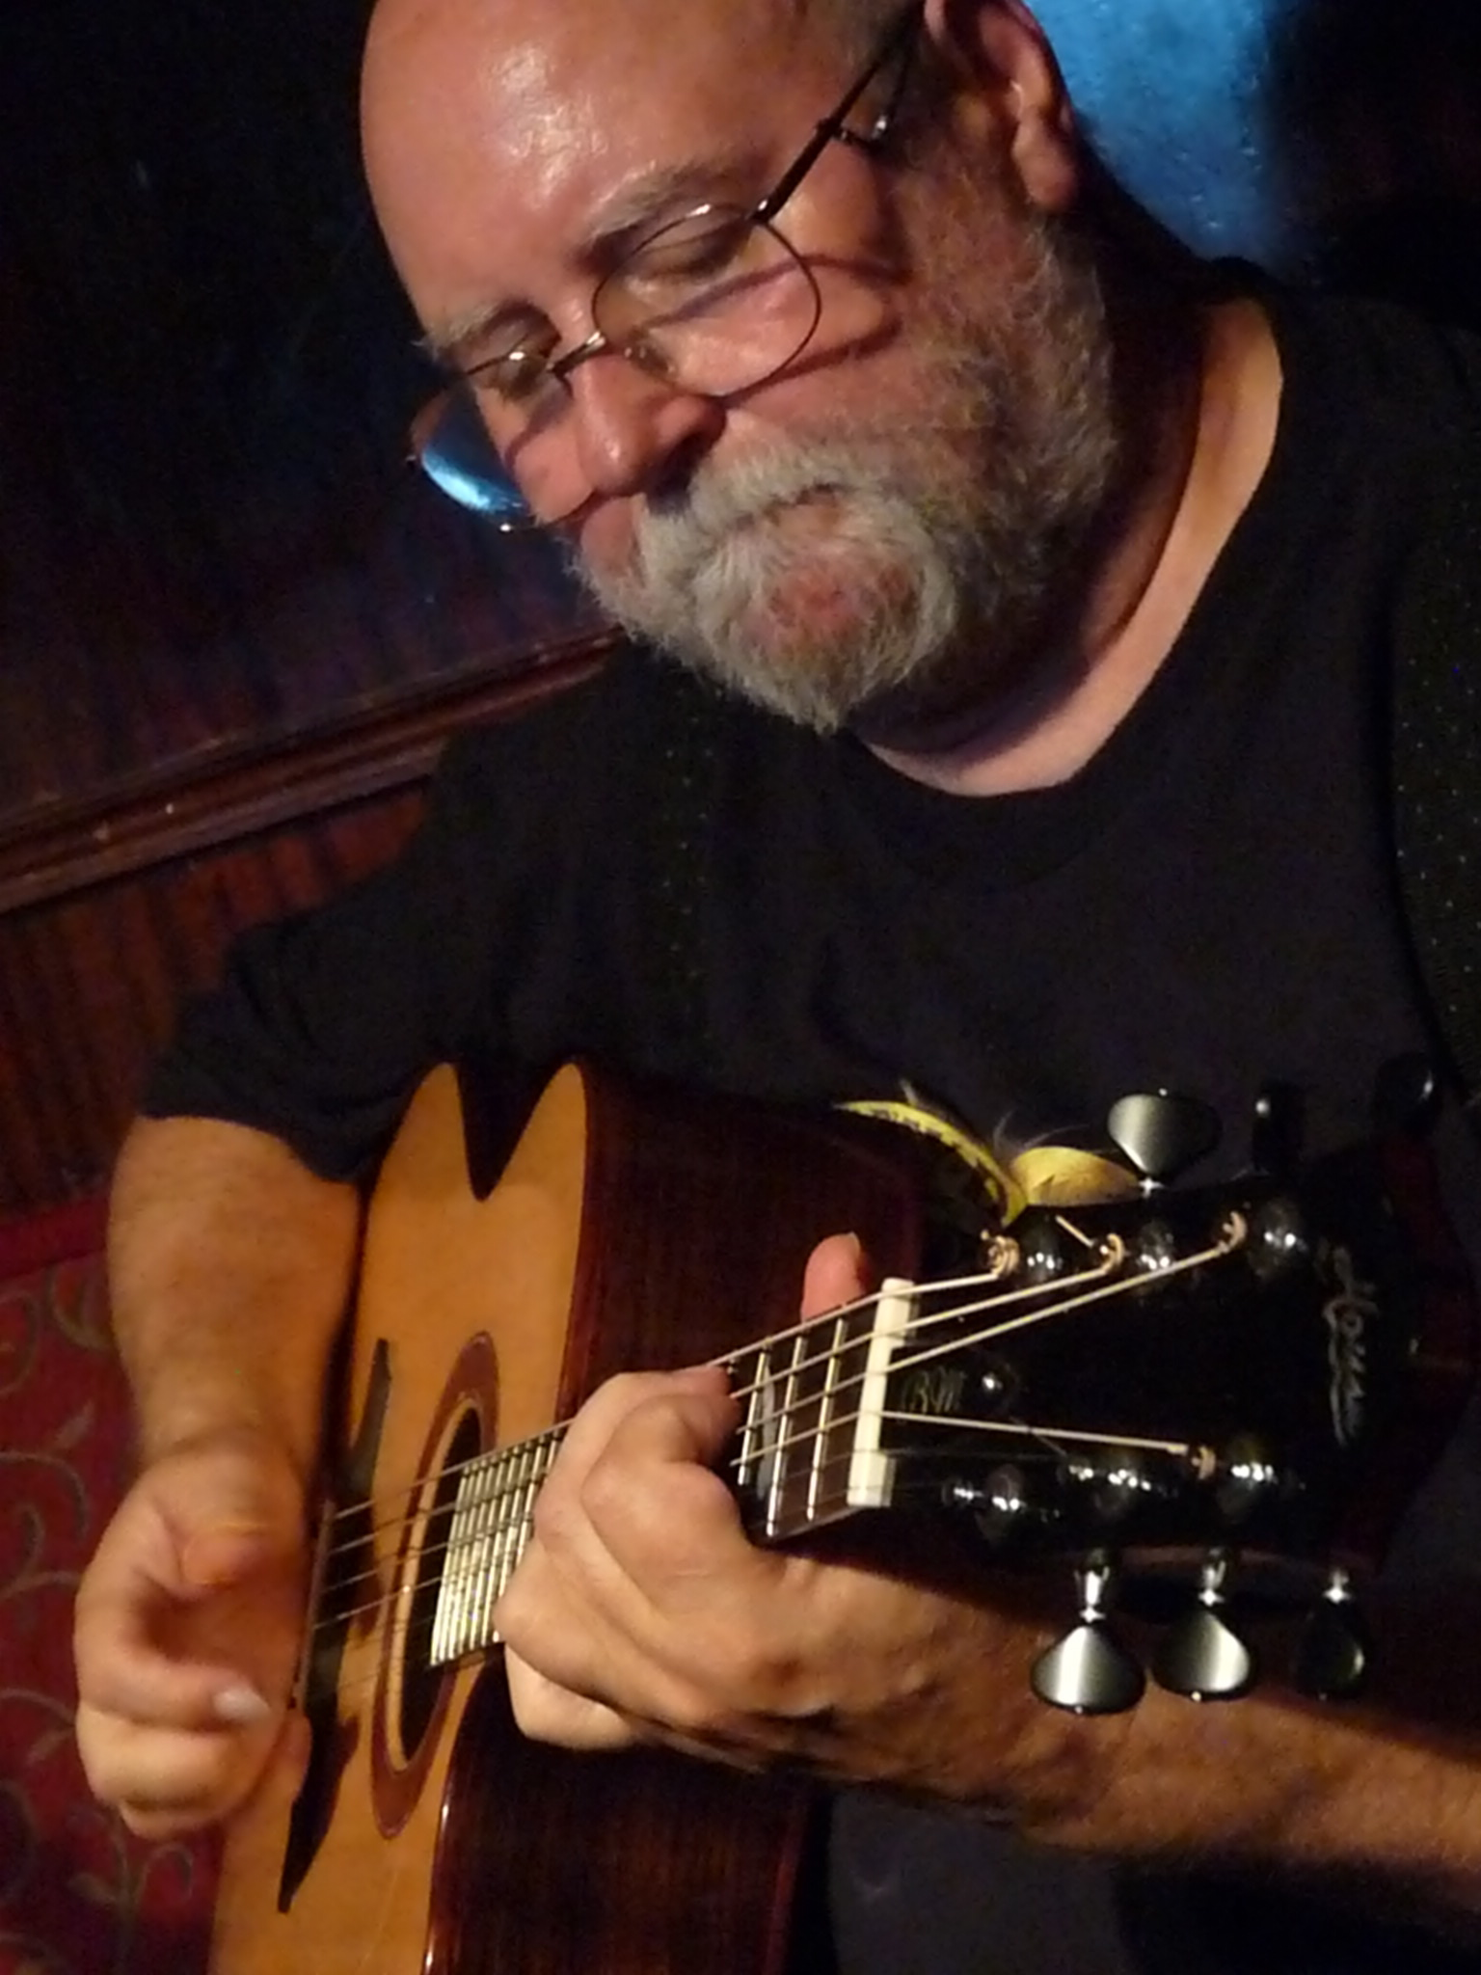
In May, a career first! For thirty-odd years now, my friend Rod Sinclair and I have been threatening to tour together - and we’re finally going to do it. The catalyst was a brief spot we did together at the Drones & Bellows 30th anniversary concert a year ago and it sounded so good we just had to give it a try. Rod’s a Scots exile to Denmark and a fine singer, guitarist and 5-string banjo player. The combinations of instruments and vocals we’ve already come up with sound beautiful and striking. The gigs will be in Denmark and the north of Germany. Keep an eye on my website for dates, and if you can come along, be ready to laugh a lot and sing your heart out.

The summer’s festival programme will include Cambridge Folk Festival and Goderich Celtic Roots Festival on the shores of Canada’s Lake Huron. More on those later.

My writing is now keeping me as busy as the music, and I spent much of 2018 getting my novels formatted and online as eBooks. I know many people still hanker after actual books, but there’s no doubt that the eBook format is here to stay, and - despite having a lump in my throat for the good old days of a sheaf of paper between two pieces of cardboard - I’ve decided to embrace it. That’s not to say that real books will be abandoned; watch this space.
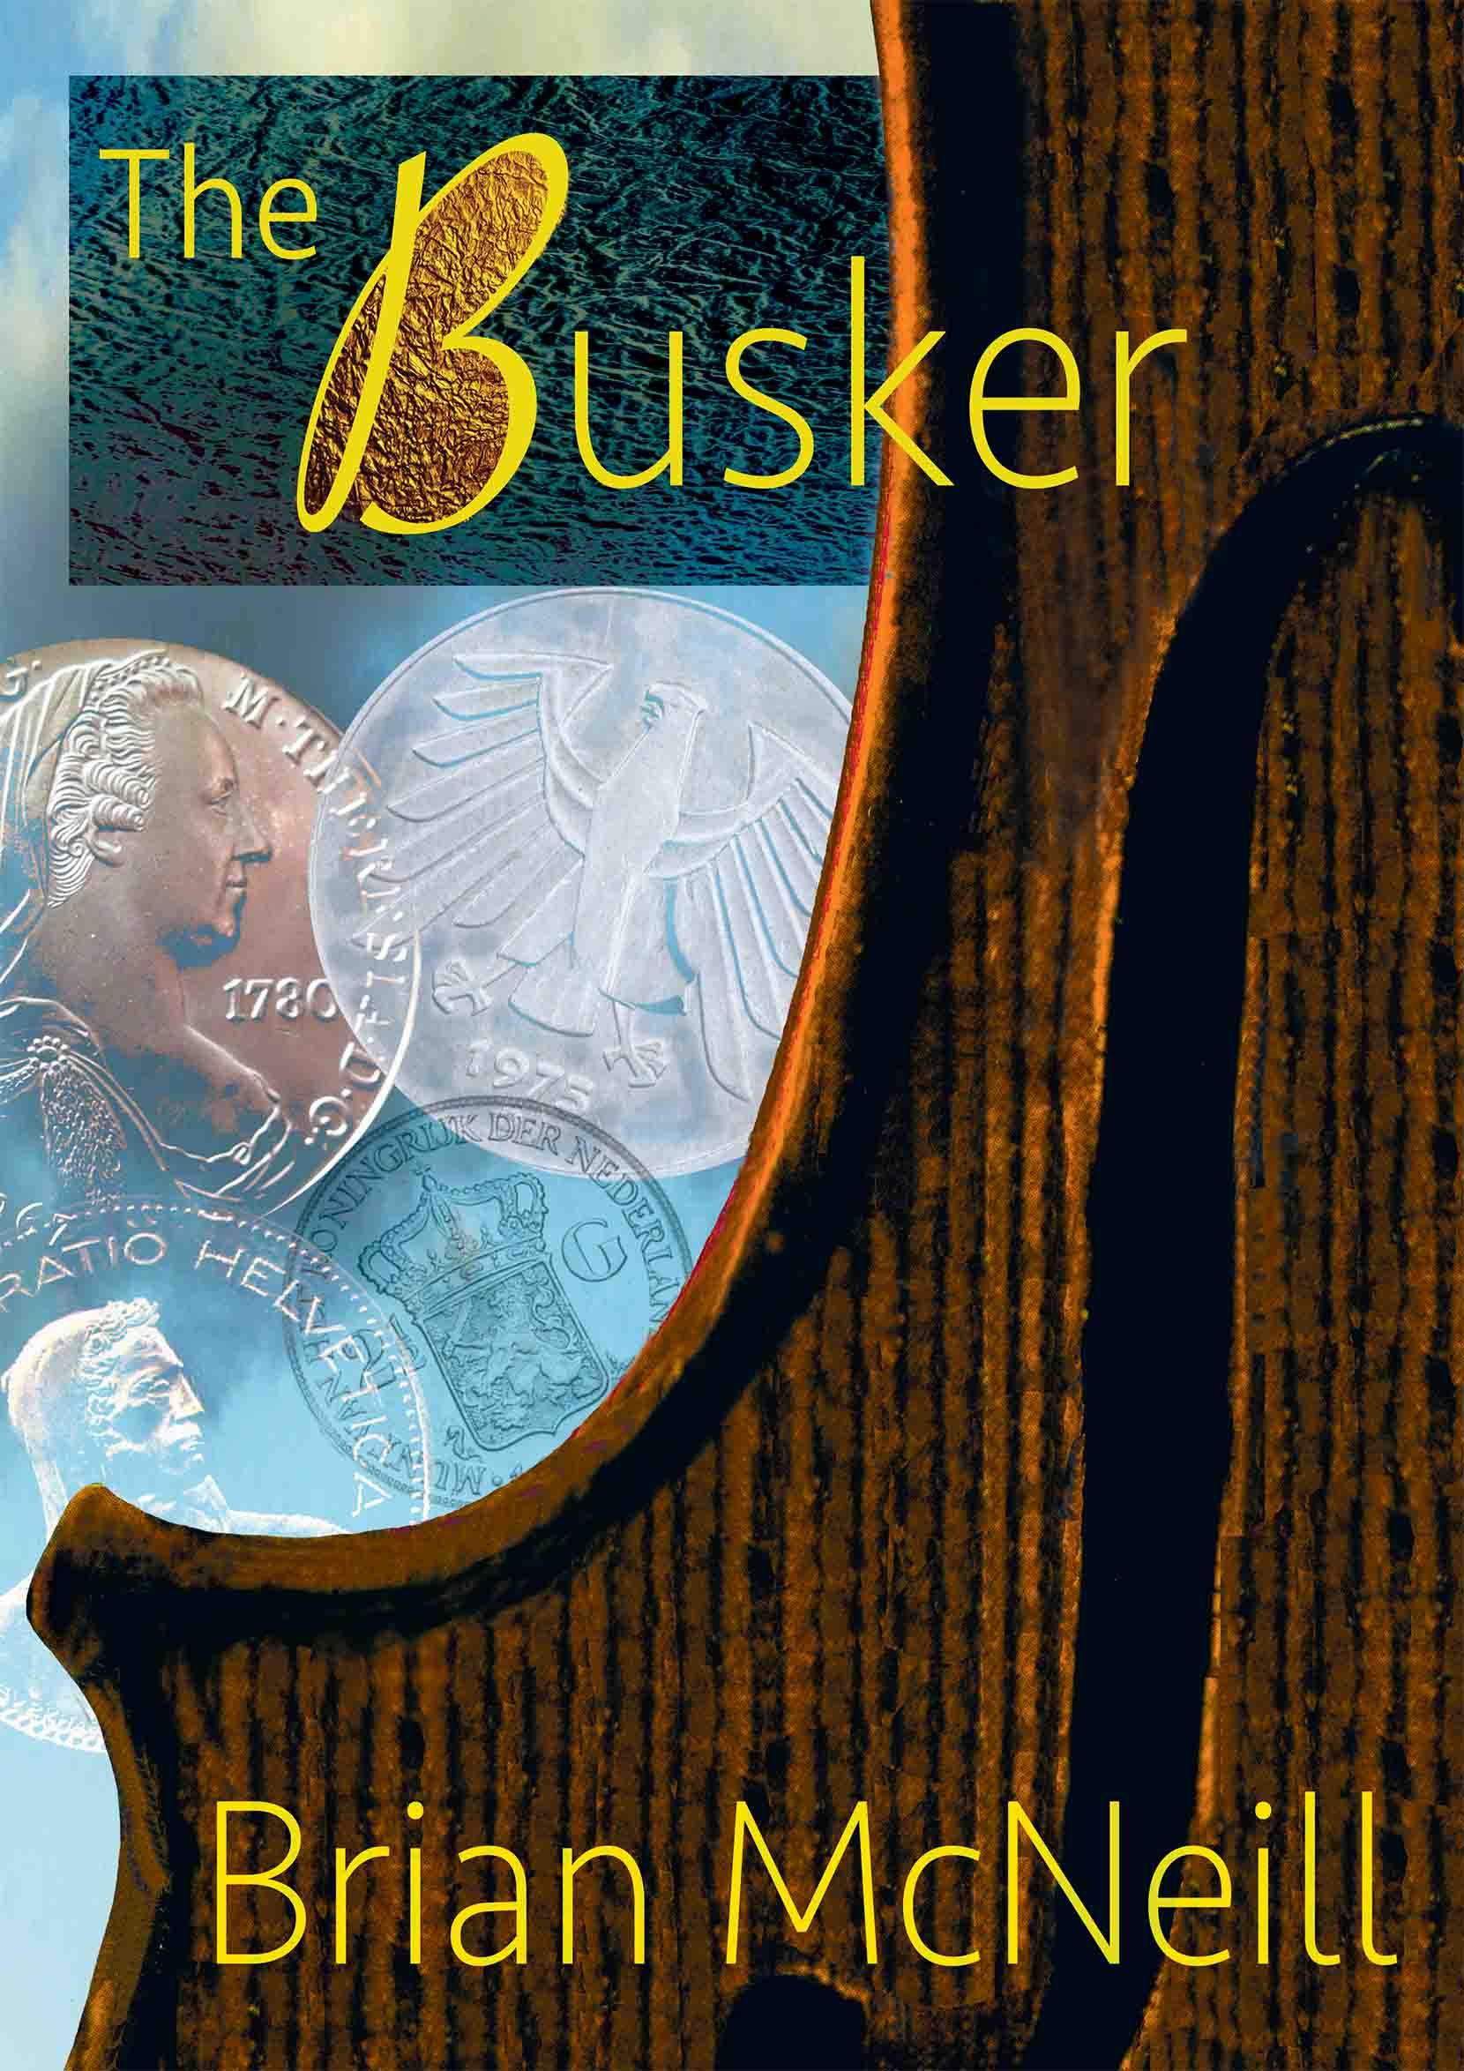
The Busker series of novels, started many moons ago on an overnight flight between Seattle and Anchorage, now numbers four: The Busker, To Answer The Peacock, No Easy Eden and The Hawk That Swoops. All are now available on Apple Books and Amazon Kindle, as is … In The Grass, the first of the Sammy Knox series. My thanks to everyone who’s bought them so far, especially those of you who added reviews.

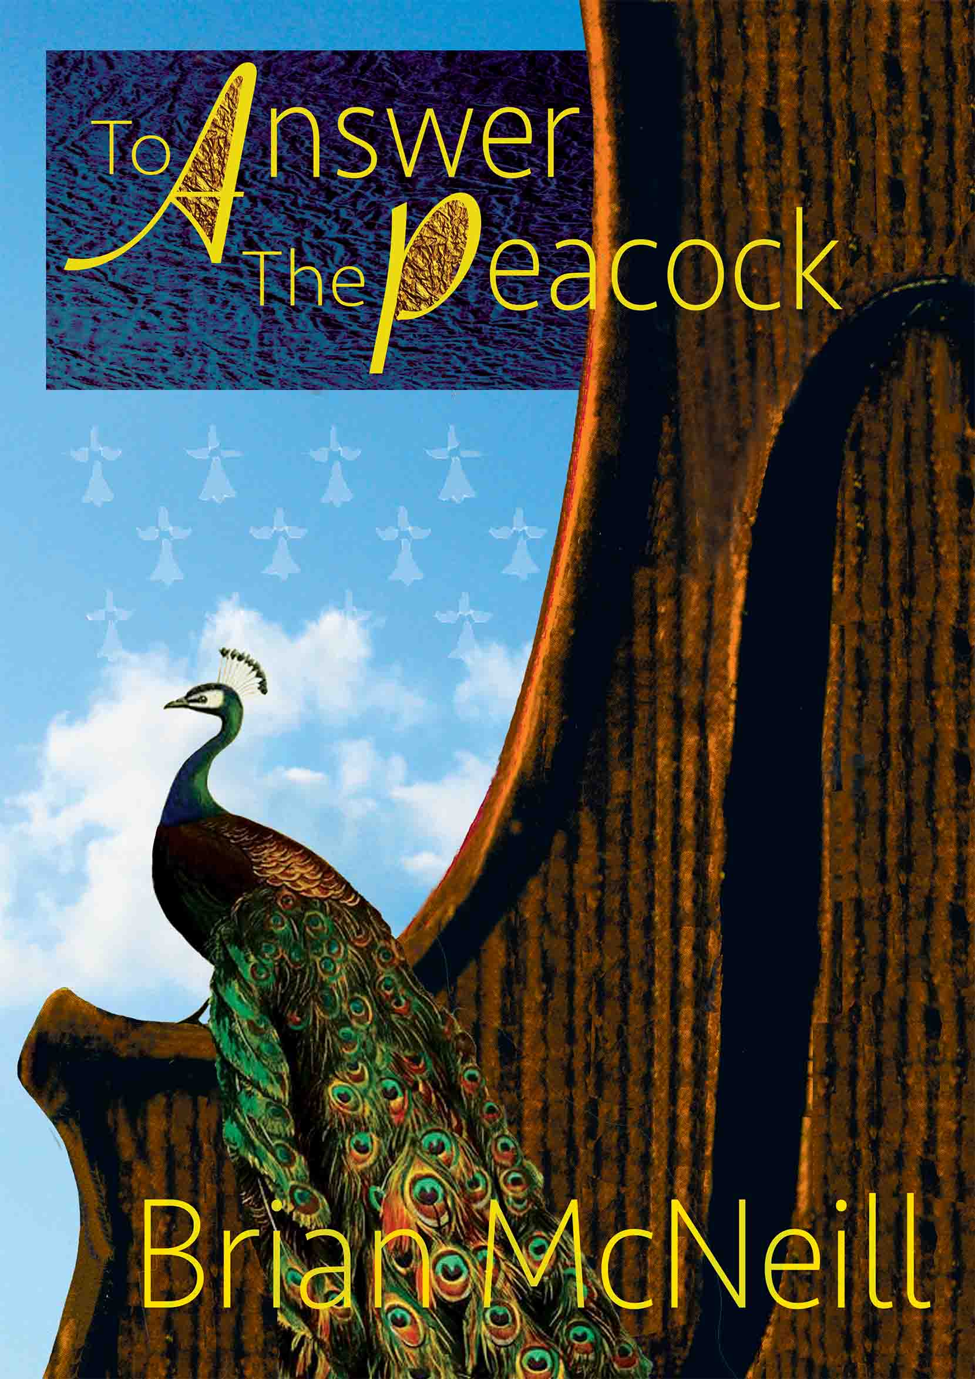
This year, they’ll be followed by a standalone novel, Blue Danube, and the next Sammy Knox adventure, … In A China Shop. I’m also finishing my first collection of short fiction, The Horseman’s Word and Other Stories.

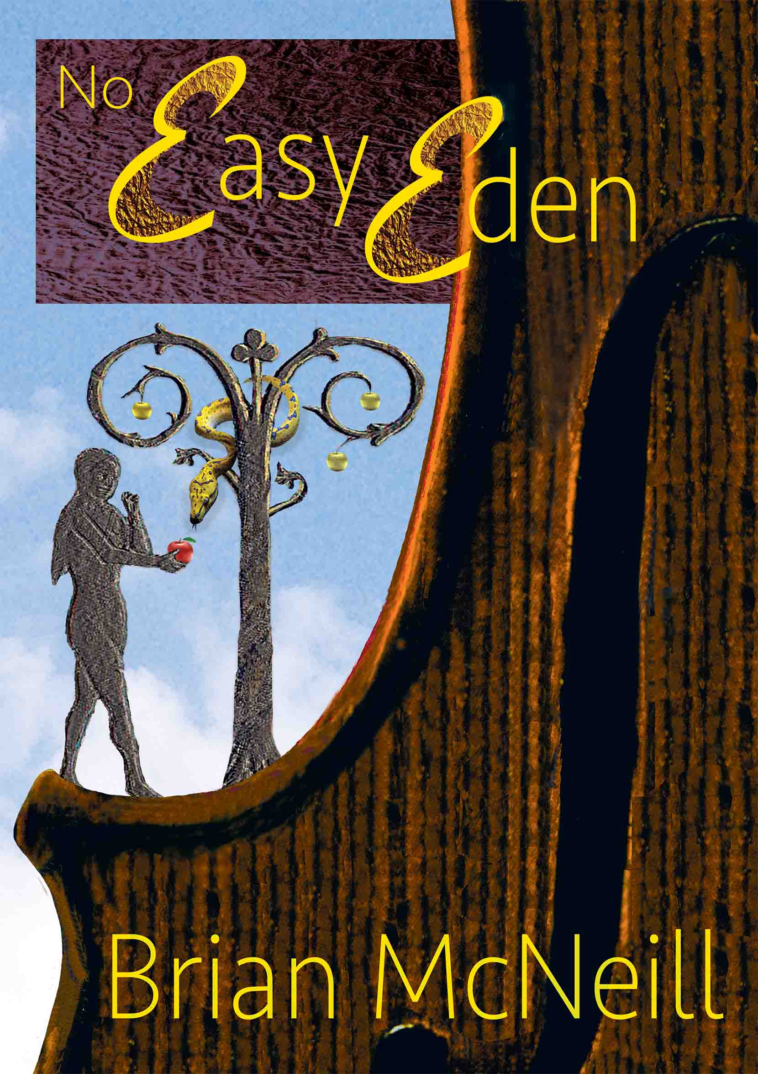
This is a side of my writing which hasn’t yet been greatly in evidence – in English at least. One of the stories, Flash Gorton’s Leg, appeared in a collection of pieces from my home town, Falkirk, called Alight Here, and several of the others have appeared in German collections, but they haven’t been brought together as any kind of cohesive whole, so now I’ve decided to take that particular plunge.

These stories, written to various degrees in Scots dialect, are important to me. Coming close to home in your work is always a daunting prospect, and the way I feel about these pieces is not dissimilar to the way I felt when I began to write songs about my homeland. I hope you’ll give them a try. For those among you who’ve not had the benefit of an upbringing surrounded by lowland Scotland’s tongue, I’ve included a glossary.
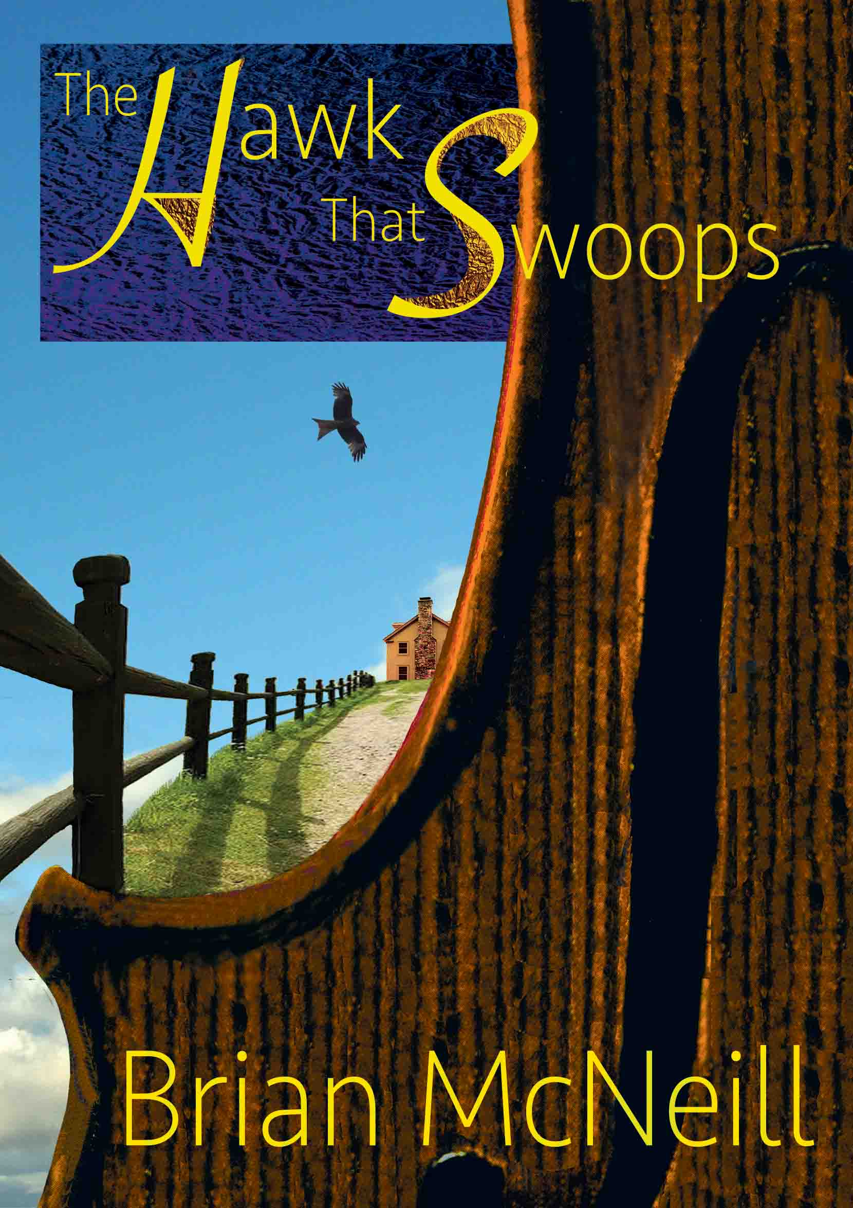
One last and important thing.

This mailing list hasn’t been put together by simply culling addresses from my contacts book - everyone has been asked if they would like to be here. If you decide you no longer wish to be included, please just let me know. And if you know anyone you think might like to be added, ask them to email me at the above address.

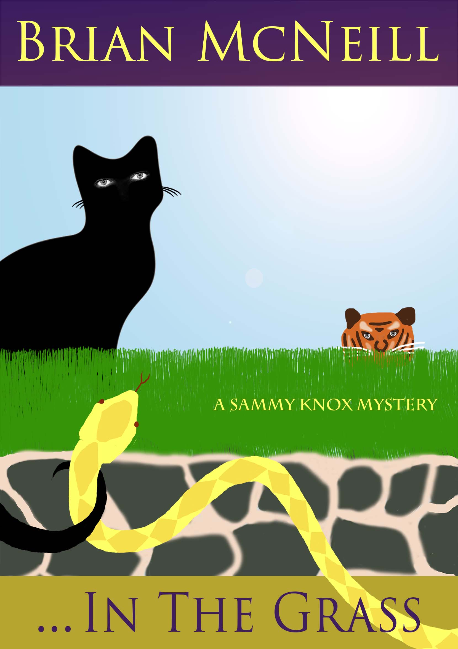
I’d enjoy hearing back from you.

All the best,

