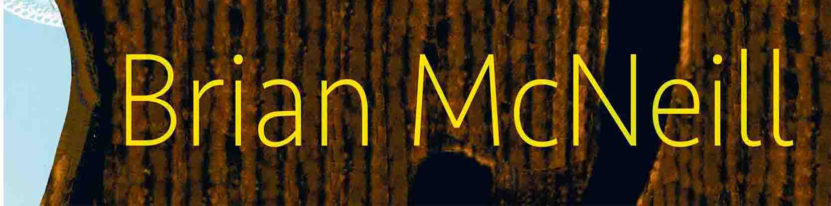

Brian’s Website

brian58@talktalk.net

Hi everyone, and apologies, it’s been far too long since I was in touch, but I’ve been pretty much nose to the grindstone since the last newsletter.

Anyway, hello from a muggy and hot St. Louis, where I’m beginning my annual stint of teaching Scottish music to the orchestras of the city’s excellent schools. My thanks go to SPAE, the wonderful Scottish Partnership for Arts and Education, and to its indefatigable organiser, Diane McCullough and her dedicated board.

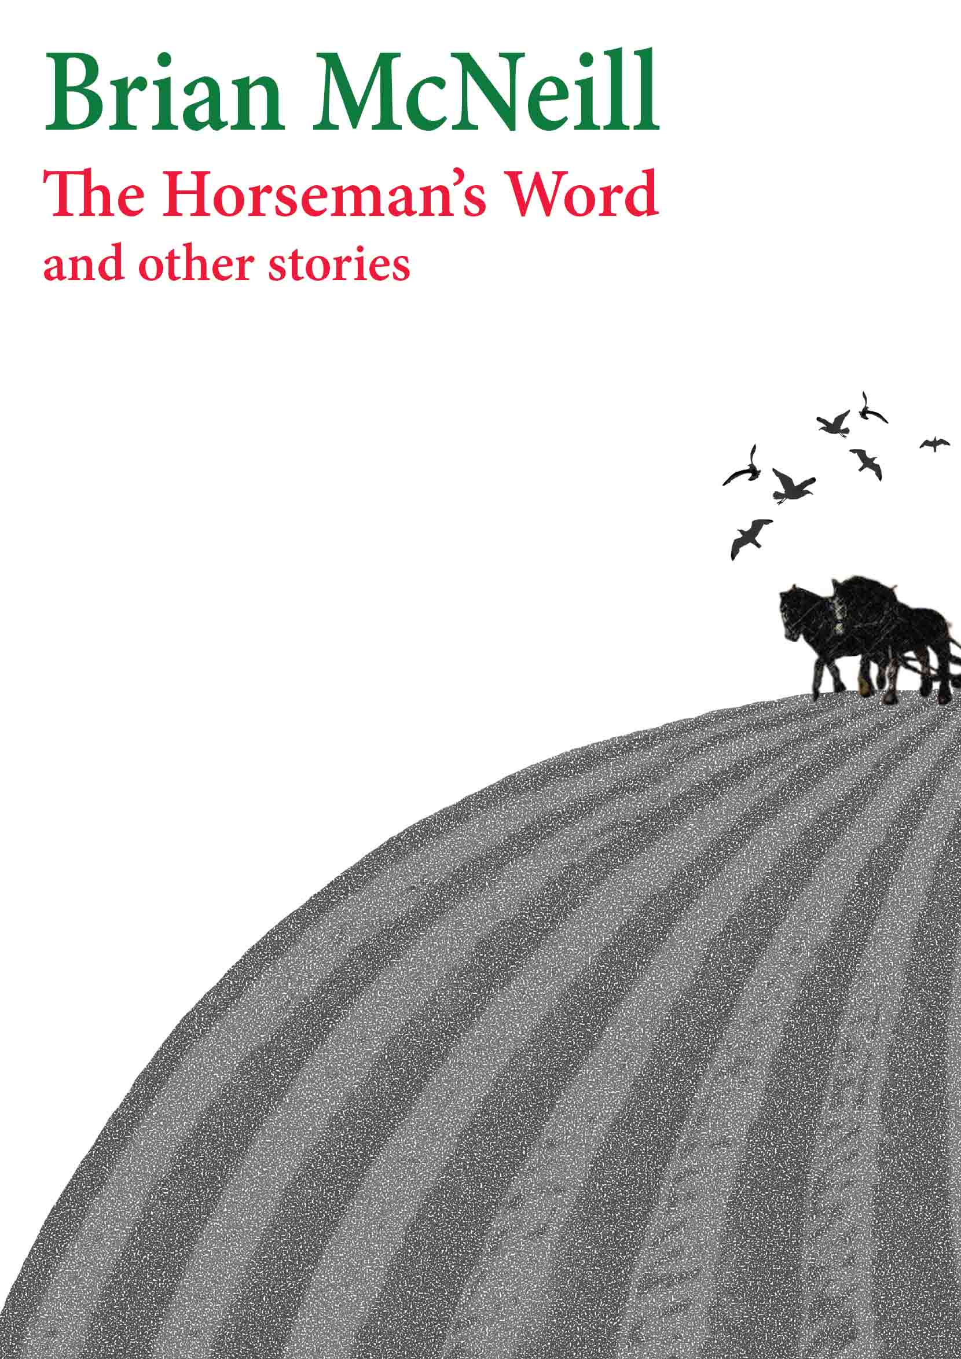
Let me start with the latest news. My first collection of short fiction, The Horseman’s Word and other stories, has just appeared as an eBook, in both Apple and Kindle formats. To those of you who prefer having an actual book in your hand, I apologise for the promised print copies not coming out at the same time as the electronic ones. They will appear, in both English and German, in the near future. My publisher, the excellent Songdog, is working on the paperback versions. Watch my website for news of their arrival.

These tales… I do confess to being proud of them. As I’ve said before, it’s always a big challenge for a writer to come back to his home turf, and all but one of the stories here take me back there. No matter how far I travel, the pithy heritage of lowland Scotland’s vernacular tongue will always hold me, and I hope this book reflects the language and expression which so deeply influenced my childhood and adolescence – and which still pervades so much of my songwriting. I’ve made no attempt at all to soften dialect – I believe that the voices I’m presenting here, my own included, should be given full rein - but for those who might find it a struggle, there is a glossary. The final story in the collection, The Last Battle, is a response to the many readers of … In The Grass who wanted Scrapper, the feline sidekick of the book’s heroine Sammy Knox, to have the chance of telling at least part of his own story. Other episodes will follow.

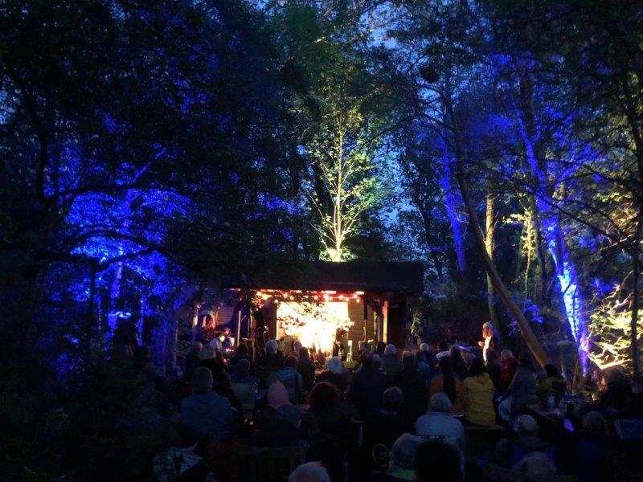
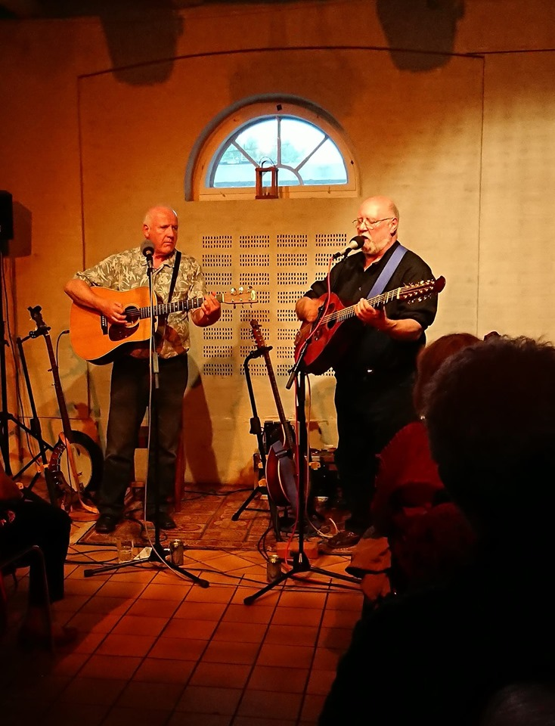
On the music side, my late spring and summer were hugely enjoyable. The tour Rod Sinclair and I did in Germany and Denmark was even more fun than expected, and it was very well received. It’s hard to pick out highlights, but the open-air gig we did for our old friend Rolf Reinstrom at LomaLoma in Altenmoor was certainly one, as was the concert at Jægerspris in beautiful North Zeeland. Of the material we played, I’m still walking around humming the haunting tune of Face The Foe, a poem by Norwegian Nordahl Grieg, which Rod set to music. It’s a highly atmospheric piece which gave me a fine chance to improvise on my octave fiddle. It’s always good to have different facets to add to my music, and I have to say that, over the whole gig, our two repertoires dovetailed beautifully and opened up some significant new directions. The response was such that there is no doubt we’ll repeat the exercise; for a touring musician, there’s not much to beat the combination of good music, lovely audiences, stunning countryside and bucketloads of laughter.

After Germany and Denmark, I spent a month or so buckling down to various writing projects, the most pressing of which is … In A China Shop, the second in the series featuring my shape-shifting detective Sammy Knox - and also, of course, Scrapper! The highly anarchic and devilish storyline is coming together nicely, but my problem with it is that new wrinkles of plot keep arriving in my head, usually in the small hours, and I always want to include them. People always ask me how I get my ideas, but I have to confess, that’s never my problem – my problem is getting them all in!

After the relative calm of my writing break, my wife Jacqueline and I drove south of the Thames, to play my favourite pub gig, Rochester’s Man Of Kent as a prelude to Cambridge Folk Festival. We arrived at the festival earlier than usual in order to hear one of my great heroes, Ralph McTell. I have to say, he’s lost none of the magic – the new songs were just as compelling as the old ones, and the ragtime piece he played showed he’d lost none of his stunning guitar skills – I’ll always remember the weeks I spent in my unheated flat in Glasgow’s Battlefield, trying to learn his version of Blind Blake’s Rag. He finished, of course, with Streets Of London, but you’d have been hard pressed to work out whether he sang it to the audience or they sang it to him. A wonderful start to a great weekend.

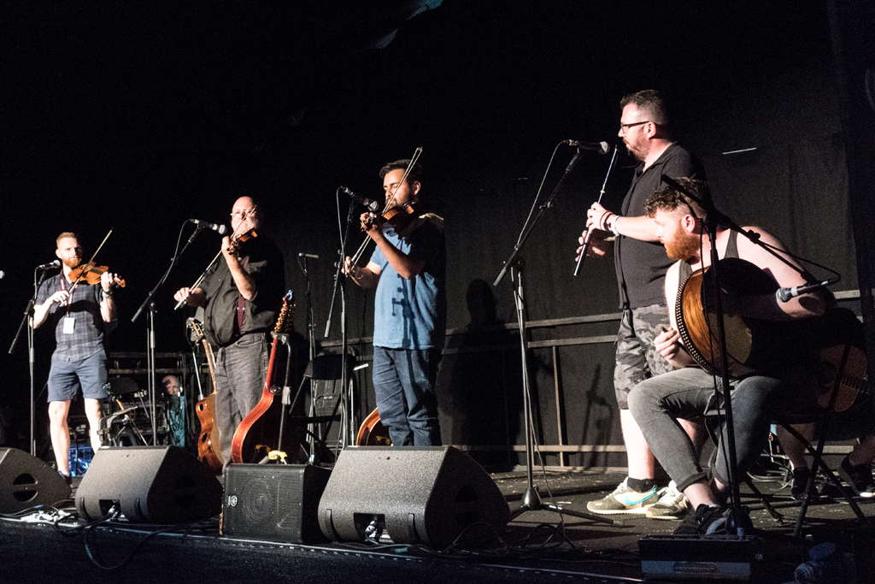
Cambridge is one of the great events of Britain’s folk revival, and I’ve been fortunate enough to be booked there for many years now – I’m officially the longest running booked artist at the festival! The Club Tent, which I usually play on the Friday night, is a distillation of the best of the British folk club scene, a place where sensitive material is listened to with thought and the raucous is made even more so by an audience always ready to let rip. My thanks go to my friends Matt Tighe and Kevin O’Neill for joining me at the end of my set, along with Rura, that phenomenal young Scottish band, some of whom I’ve had the honour of teaching. My thanks to Neil King of the excellent Fatea magazine for the superb Cambridge photos.

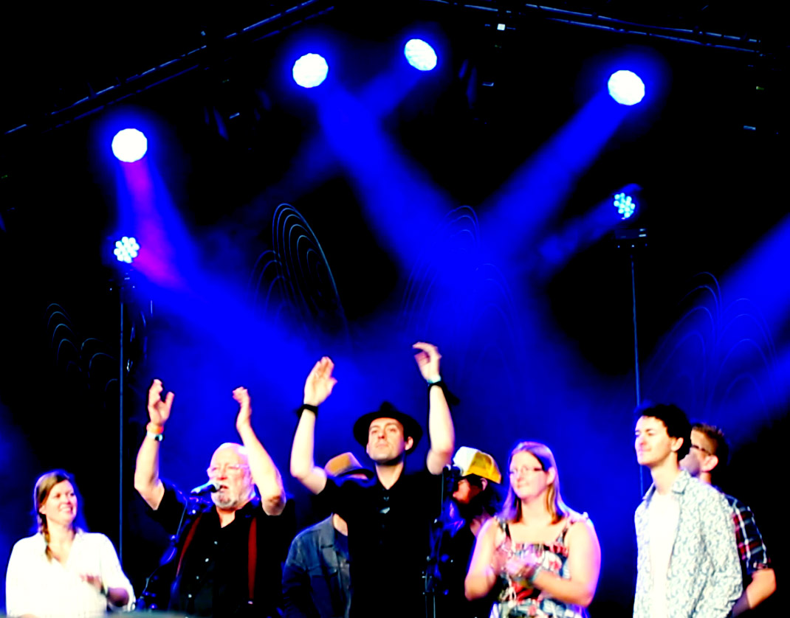
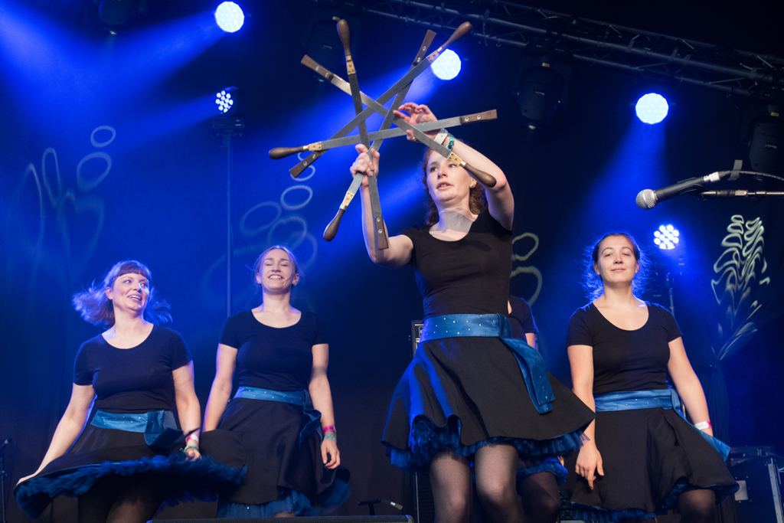
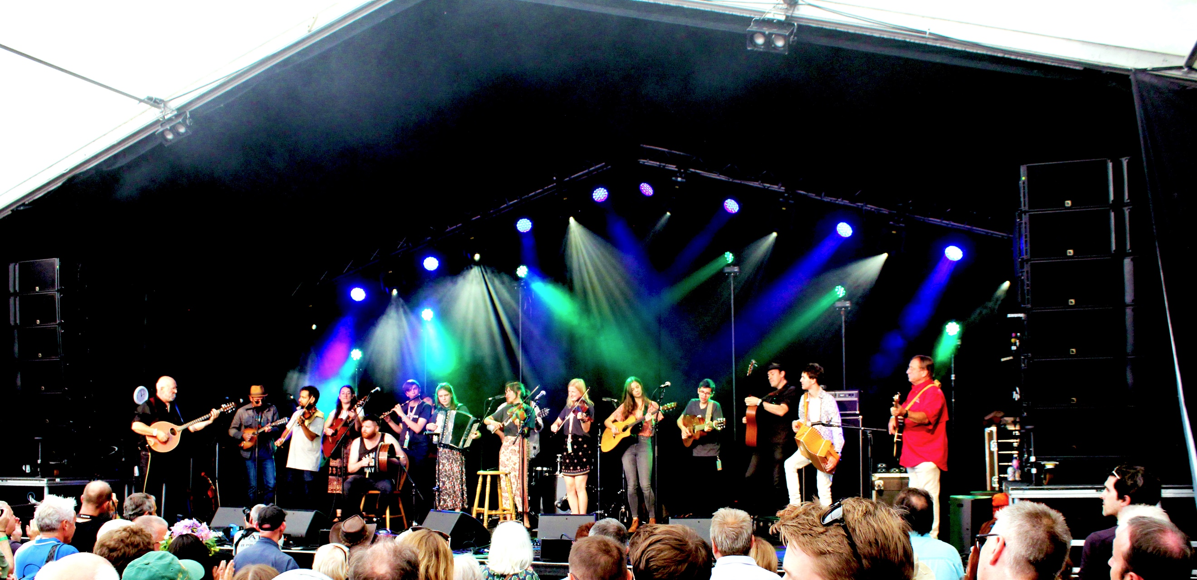
Saturday lunchtime, however, is the main reason I’m at the festival. Cambridge’s Stage 2 Session has now become an institution. The original idea was to make a showcase where the audience could get a taste of many of the acts booked, but it’s developed into a great deal more than that. The watchword is now collaboration. Backstage, before the event starts, you’d hear celtic music meet blues and bluegrass, see soloists merge into impromptu bands, and generally watch a fair bit of anarchy get ready to launch itself on stage. This year, there were far too many wonderful acts and musicians to mention here, but particular thanks to my old Canadian friends The Once for overcoming a scheduling problem and belting a hundred miles down the motorway to make sure they didn’t miss it. On my website you’ll find a video clip which gives a feel of the Session. (Although why nobody captured my Chuck Berry impersonation remains a mystery...) My thanks, as ever, go to the excellent stage and production crew who always make my life so much easier.

Sunday found me, bleary-eyed, on a flight to Toronto for another of my favourite gigs, Ontario’s Goderich Celtic Roots Festival.

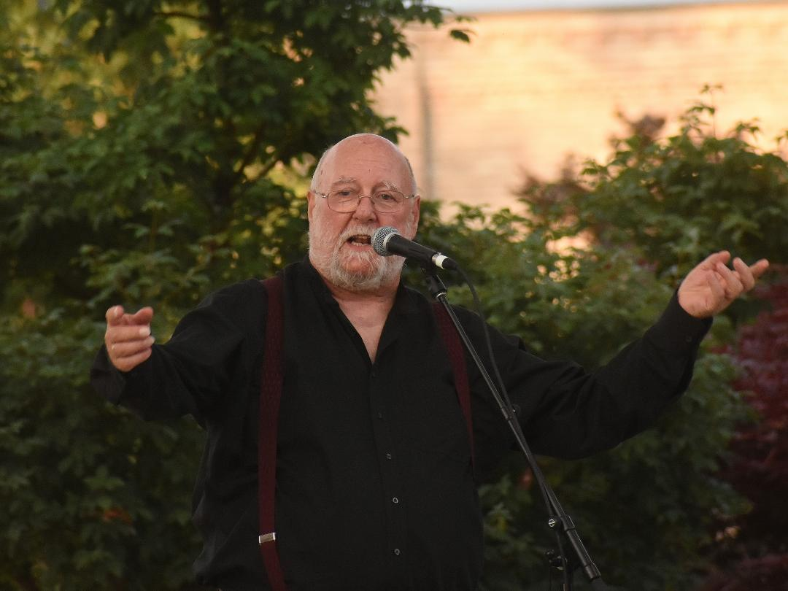
Goderich is a wonderful town on the shores of Lake Huron, and its festival is committed to both performing and teaching. The week-long teaching arm, the Celtic College, attracts top instrumental, vocal, dance and craft teachers from all over North America and Europe, there are performances every night in the town square (the picture’s of me singing Rowdy Soul, a Mississippi river shanty, on stage there) and then at the weekend, we all go down to the lovely park by the lake and sing and play our hearts out. This is a festival like folk festivals used to be – warm, welcoming and firmly rooted in its host community. My thanks and congratulations go to Cheryl Praschker for an excellent debut as festival director – seamless organisation – and to my old and dear friends Warren and Eleanor Robinson, for keeping traditional music’s flag flying in Ontario with such flair, and for so long.

One other thing. I have to say how much it pained me to hear of the passing of fRoots, Britain’s premier folk scene magazine. My thoughts and sympathies are with their hard working team, led so capably and diligently by Ian Anderson, for holding the banner of our music so high for so many years. A sad loss.

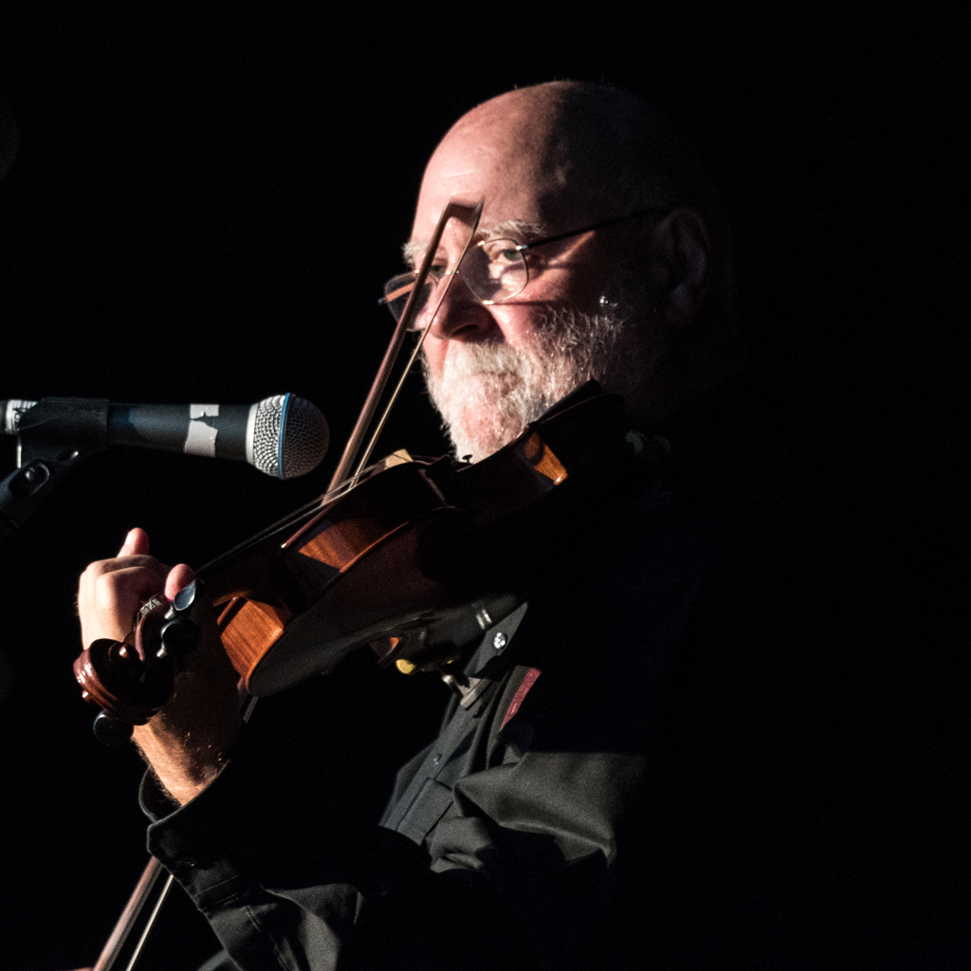
Finally, may I repeat that this mailing list hasn’t been put together by simply trawling for addresses - everyone on it has been personally asked if they would like to be here. If you decide you no longer wish to be included, please let me know. And if you know anyone you think might like to be added, please ask them to email me at the above address.

And, as always, I’d enjoy hearing back from you.

All the best,
